Small user guide for the tier3app

1.Current page, it doesn’t contain any information, but links. 2

2. Books: 3

3.Users: 4

4. History: 5

## 1.Current page, it doesn’t contain any information, but links.

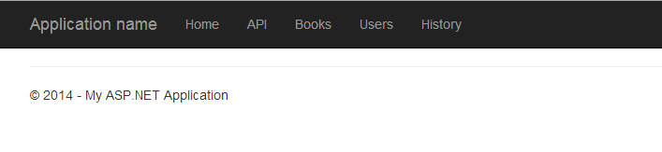

## 2. Books:

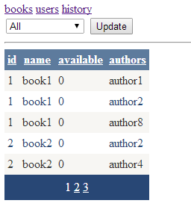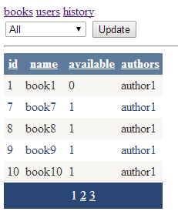

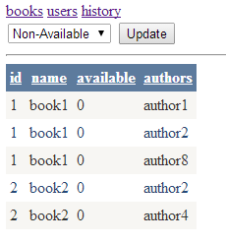

* Books, users, history – are links.
* Contains sorting by id,name,available,authors.
* Contains filtering by available.

## 3.Users:

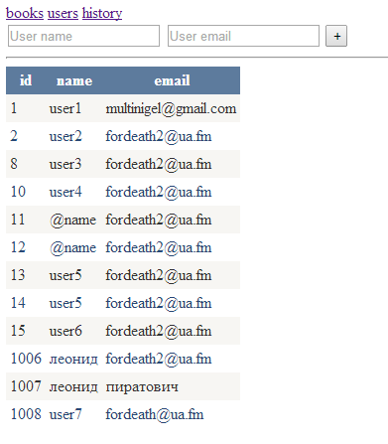

* You could add a user .

## 4. History:

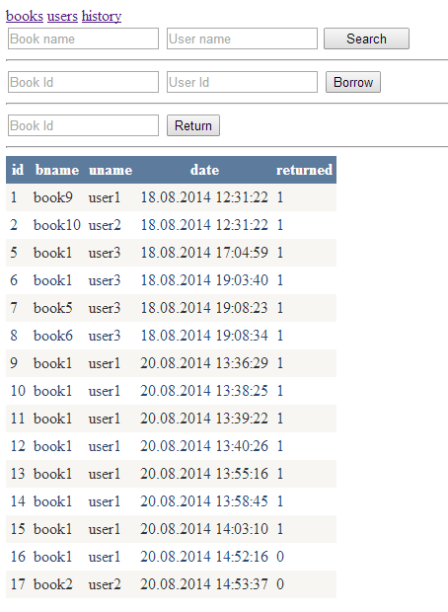

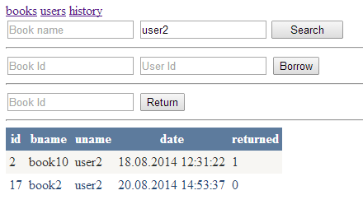

* You could track book or user in search-form.
* Borrow a book in borrow-form.
* Return it in return-form.